**Website Documentation**

**Grill & Chill Restaurant Website Project**

**Course:** Intro To Web Development

**Group Members:** Kabelo Zondi, Don Yemweni, Bokamoso Moemisi, Siyabonga Mabuza, Godlove Mpofu, Zaid Williams, Grace Dedou, Josephine Ilunga, Michele Kamonga and Aiden Lodewyk.

**Submission Date:** 20th Of June 2025

1. **Project Overview**

**Project Title and Description.**

As a team of ten members, they have created “Grill And Chill” a fictional restaurant website exhibiting their brand story, products and “motto”. The website aims to equip and provide the users/customers with all the relevant information about the restaurant while displaying a delightful yet age-friendly environment that reflects the restaurant’s image.

**Team Members and Contributions.**

**Kabelo Zondi**: Website design layout, as well structure for the beverages page and documentation coordination.

**Don Yemweni**: Main Course html and internal CSS.

**Bokamoso Moemisi:** Homepage, login form, and ratings page creation.

**Siyabonga Mabuza**: Bookings page creation and reference provider.

**Godlove Mpofu**: Logo Design and Theme enthusiast.

**Zaid Williams**: Desserts page creation and background.

**Aiden Lodewyk**: About us page creation and link alignment.

**Michele Kamonga**: Menu linkage and css styling in entire menu section.

**Josephine Ilunga**: Image alignment in all webpages and appetizers in menu.

**Grace Dedou**: Creation of Kids Section and both inline and internal Css implementation in Kids section.

**2.Website Structure**

REVIEWS PAGE

BOOKINGS FORM

ABOUT US PAGE

All these web pages are connected through a yellow navigation bar, with consistent linkage.

* Homepage(index.html)
* Menu(Main Courses.html/Drinks.html/Dessert.html)
* Kiddies(grill kids menu.html/toys.html)
* Bookings form(Booking.html)
* About Us(About Us.html)
* Reviews(Review.html)

**Page Descriptions**

**Homepage** (index.html) The homepage serves as the main entry point to our website. It features:

• A large centred logo image of the restaurant.

• A welcome message describing the restaurants’ working hours as well as featured meals.

• Navigation tab to visit pages (menu, kiddies, reviews, about us).

Contains a link to those who have an account to login…

**Menu** Page (menu.html)

This page displays is broken down into 3:

* Main courses(Main Courses.html):

Image layout, pricing and order buttons.

* Desserts Page(Dessert.html):

Types of desserts, pricing, order and dessert special.

* Drinks Page(Drinks.html):

Portrays drinks from standard to exclusive provided with images, pricing and age restriction statement.

**Kids Section**(Kiddies)

A section created for the younger customers, mainly before the adolescent age. Comprises of 2 pages.

* Kids Menu(grill kids menu.html):

Has images, pricing of kids meals as well as preferred beverages. Contains links to joining kids club as well as earning toys.

* Toys(toys.html):

Consists of a collection of toys available for the kids and link to join club.

**Bookings Page**(Booking.html):

Consists of a form that requires details in order to book a table.

**About Us page**(About Us.html):

Provides information about the restaurant’s motto, purpose, value as well as links to social media platforms.

**Reviews Pag**e(Review.html):

Contains some reviews from previous customers, services that were admired as well as comments based on the restaurant.

**Navigation Explanation**

All pages have a consistent yellow navigation bar, may differ in position across the website but remains visible to the eye. The current webpage ensures that users can understand navigation within the website. A footer is also included in most of the webpages, providing contact details.

1. **HTML Elements Used Key HTML**

**Content and Media Elements**

* H1 and H2, maintained throughout.
* <p> used for paragraph text and labelling.
* <img> used for all images with relevant text.
* <table>used for displaying working hours on homepage.
* <ul>used to link webpages as well as text alignment.
* <br> to separate content in lines.
* <font> to display font and color.

**Form Elements Used:**

* <form> container for the login form and booking form.
* <input> Various input types(email, password,etc)
* <text area> mainly used for message input.
* <label>/<option> for dropdown selection of inquiry type(ratings)
* <button> for submit and login button.

**Screenshot Examples:**

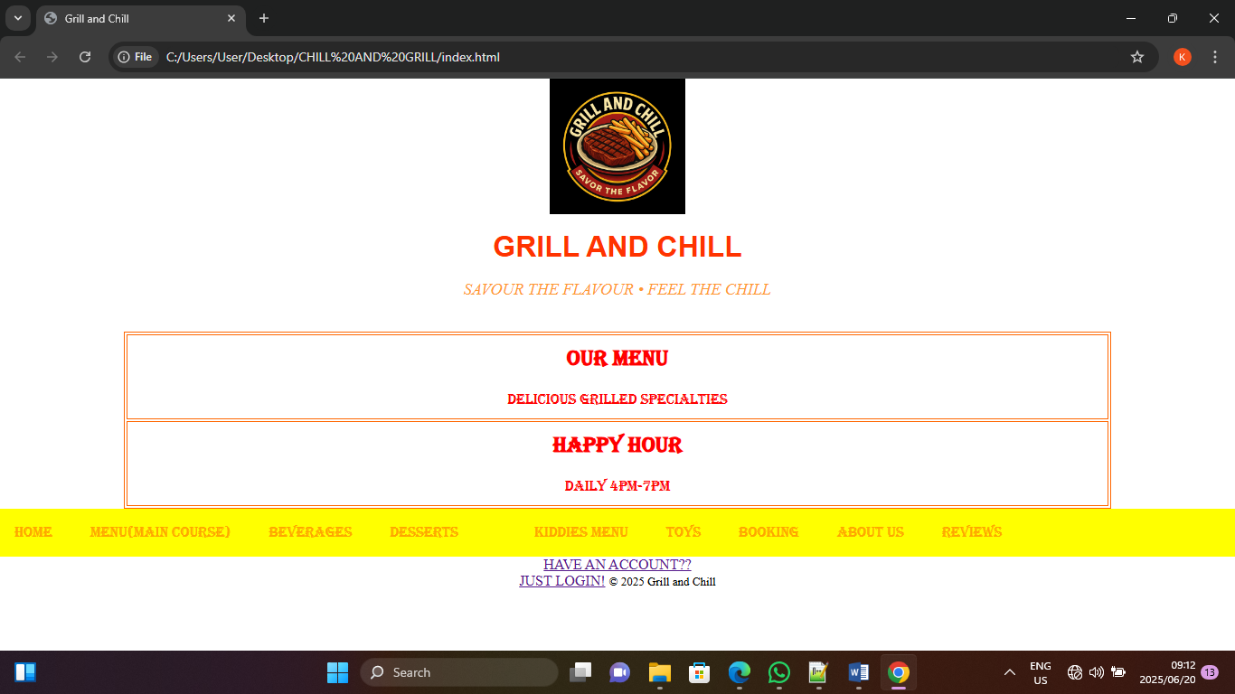

Header used with <h1> tag.

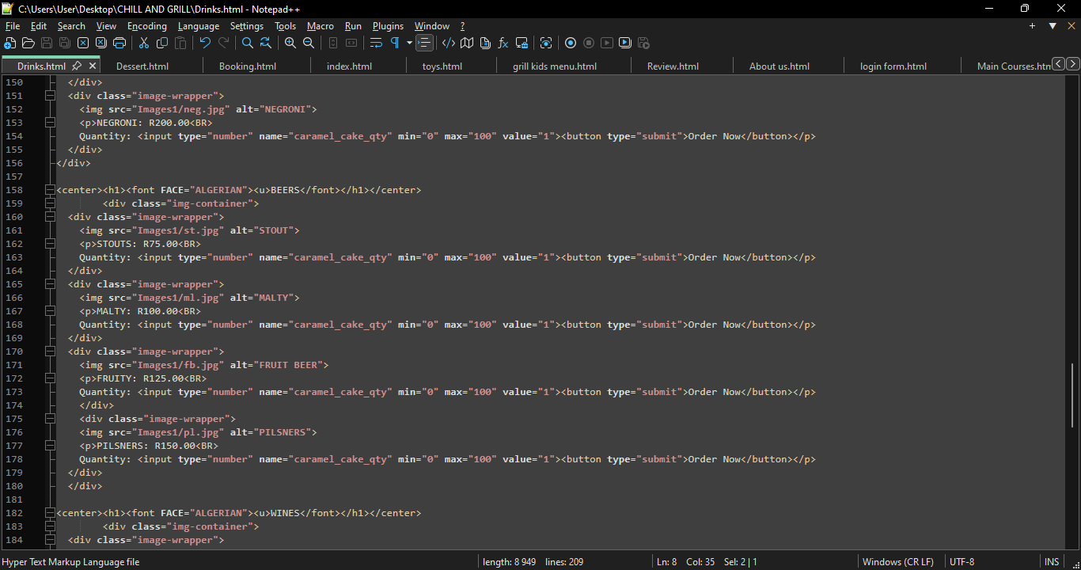

**Used** various elements and tag such <div>, <img> as well as classes.

|  |
| --- |
| 1. **CSS Implementation CSS Properties Researched and Applied Layout**   Properties:  • display: Used flex display for navigation and card layouts  • margin and padding: Applied to create consistent spacing  • width and max-width: Used for responsive container sizing  • position: Applied for the fixed navigation bar Typography Properties:  • font-family: Selected "Algerian" and "Sans-Serif" from Google Fonts  • font-size: Varied sizes for different elements following a coherent scale as well as headings.  • text-align: Used for centering headings and particular text blocks Colour and Visual Properties:  • color: Text colours using a defined palette  • background-color: Applied to different sections • border and border-radius: Used for buttons and card elements  • box-shadow: Applied subtle shadows to create depth Color Scheme and Design Choices.   1. **References and Resources HTML and CSS Learning Resources**   • W3Schools HTML Tutorial: https://www.w3schools.com/html/ • CSS-Tricks Flexbox Guide: [https://css-tricks.com/snippets/css/a-guide-to flexbox/](https://css-tricks.com/snippets/css/a-guide-to%20flexbox/)  • HTML5 Doctor (Semantic Elements): http://html5doctor.com/ • YouTube Image and Content Source(brocode/learn htmland css)  • Logo image: kittl.com, • menu item images:  Pexels.com, various photographers (all anonymous photographers)  • Icons: Font Awesome (free version) All images used were created by team members.  Appendix: GitHub Repository Our project is available at: https://github.com/459-kb/BRAIN-STORM/ The repository contains all HTML files, CSS files, images, and documentation.  Bottom of Form |